Mentored Faculty Fellows
2023/2024
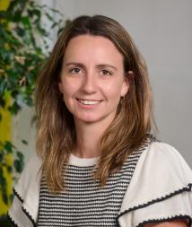
Jimena Cosso, Assistant Professor, College of Education
The fellowship will support Cosso’s research to advance knowledge of Latine parents' engagement with their children at home in mathematics. Her goal is to address educational inequalities by improving the commonly used measures to assess the home mathematics environment that do not consider cultural differences. Cosso will focus on creating partnerships with Latine communities in the area and conduct confirmatory factor analysis of a new scale that she developed to properly measure the home mathematics environments of Latine families. .

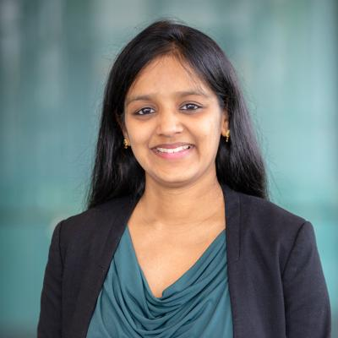
Sudha Veturi, Assistant Professor, College of Health and Human Development and Eberly College of Science
Veturi will use fellowship support to acquire the additional training and knowledge she will need to understand the biological underpinnings of stress and its temporal relationship with neurodegeneration. Her long-term goal is to establish an independently funded research laboratory that conducts scientific research at the intersection of statistics, genetics, clinical/biomedical informatics, and neuroscience to solve challenging public health problems, particularly neurodegeneration due to aging. Veturi also aims to develop scalable statistical methods and computational workflows that can handle multimodal datasets and conduct high-quality research that is dedicated to improving cognitive health in aging population in tangible ways, especially among high-risk underrepresented groups.
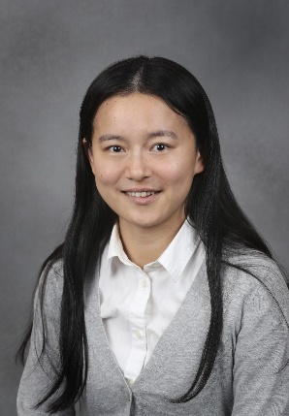
Hanyi Min, Assistant Professor, College of the Liberal Arts
The fellowship will support an interdisciplinary project that aims to understand workplace stressors experienced by homecare workers. Min will study these workplace stressors to develop interventions to reduce negative impacts. She also plans to use inductive methods, such as interviews, to understand the unique stressors of homecare workers. Building on the information collected in the interviews and the theoretical frameworks, Min will develop a framework of potential job demands and job resources for homecare workers to develop a job crafting intervention to reduce negative impacts.

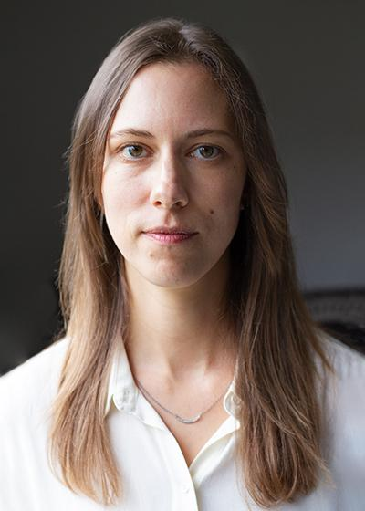
Emily T. Rosenman, Assistant Professor, College of Earth and Mineral Sciences
Rosenman will use the fellowship to support a project seeking to ascertain the geographies of the opioid industry’s marketing strategies and how the industry’s corporate and financial decision-making are related to opioid-related health outcomes. In particular, the project will make use of a new trove of corporate documents released from opioid litigation and made public via University of California San Francisco and Johns Hopkins University libraries. These data will be analyzed alongside secondary data on opioid-related health outcomes, such as mortality and overdose data, to propose an understanding of how corporate strategy may be related to geographic variation in opioid-related health outcomes. The project seeks to eventually inform policy on how legal settlements with pharmaceutical companies, as well as other efforts, could address the geographies and outcomes of the opioid epidemic.

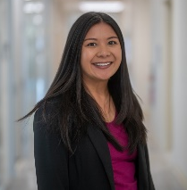
Nina Lauharatanahirun, Assistant Professor, College of Engineering and College of Health and Human Development
The fellowship will help support a project program to develop an innovative interdisciplinary computational framework to discover key neural, behavioral, and social mechanisms underlying adolescent development of health risk behavior. Lauharatanahirun’s research will be centered on developing novel computational models that predict real-world health risk behaviors such as substance abuse, unprotected sex, and distracted/impaired driving. This work will help her to identify different types of social interactions that make adolescents more vulnerable to health risk behaviors and subsequent negative health outcomes and inform future prevention and intervention efforts.

2021/2022
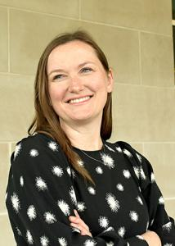
Lindsay Fernández-Rhodes, College of Health and Human Development
Genetic and Bio-Psychosocial Risk Factors for Poor Birth Outcomes and Childhood Obesity in US Hispanic/Latino Children

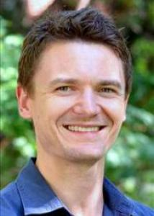
Michael Russell, College of Health and Human Development
Multimodal Ambulatory Assessment and Mobile Intervention Among Young-Adult Heavy Drinkers: Toward an Integrated Research Program

2019/2020
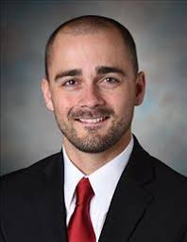
Kyle Murdock, College of Health and Human Development
Real-time, real-world mHealth measurement and novel biobehavioral mechanisms associated with metabolic syndrome

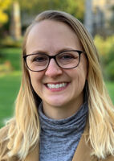
Jessica Myrick, College of Communications
Integrating Biometric Markers of Intervention Message Exposure and Emotional Responses to Improve Substance Use Interventions

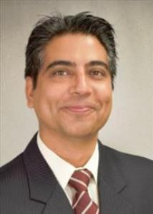
Yubraj Acharya, College of Medicine
Benjamin Fredrick, College of Medicine
Integrating Tradition with Modern Technology for Breast Cancer Screening in Ghana

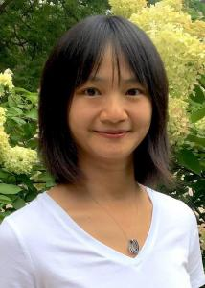
Liying Luo, College of Liberal Arts
Nativity and Gender Differences in Intergenerational Social Mobility Effects: Novel Method and New Evidence

2018/2019
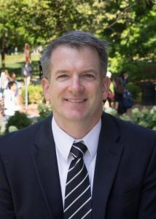
David Conroy, College of Health and Human Development
Developing a Digital Biomarker for Monitoring Musculoskeletal Injury Risk Using Personal Sensing

2017/2018
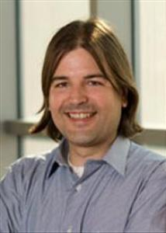
Idan Shalev, College of Health and Human Development
Integrating Dynamic Biological Mechanisms with Daily Momentary Assessments to investigate Biological Embedding of Early-Life Adversity

